U402 Systems Development

Assignment Guidance

Grant Johnson

This document aims to provide you with guidance as to how to approach certain elements of the U402 Systems Development assignment. This guidance is broken down in the relevant tasks but be aware that to achieve merit or distinction criteria you must show linkage between the themes that you investigate, all of which should be appropriately Harvard referenced. Note also that you should read the assignment and specifications thoroughly to ensure that you have a good understanding of the requirements and topics to be covered.

Table of Contents

Task 1 2

Criteria 2

Overview 2

Needs and Requirements 2

Constraints 3

Quality 3

Additional Resources 3

Task 2 4

Criteria 4

Overview 4

Task 3 6

Criteria 6

Overview 6

GANTT Charts and PERT Analysis 6

Task 4 8

Criteria 8

Overview 8

Task 5 9

Criteria 9

Overview 9

# Task 1

## Criteria

*2.1 Identify the requirements or business specification of proposed systems*

*2.2 Obtain information on existing and required inputs, outputs and processes of ICT systems*

*2.3 Explain any constraints new systems may encounter*

## Overview

Task 1 involves getting the customer requirements for what they want the software to do for them. This is therefore a non-technical document saying that the software will provide them with certain information, maybe even what they want the user interfaces to look like etc.

(Analogy: customer’s requirements for a website)

In this task you have made contact with a client who has instructed you to begin the development of a new MIS system. MIS stands for Management Information System. These are generally customised databases used to contain and manipulate business specific data. For example, primary and secondary schools make use of SIMS and CMIS (Progresso) management information systems for managing many aspects of their organisation, including:

* Attendance
* Timetables
* Behaviour
* Examinations
* Assessment
* + Much more

Your organisation may make use of an MIS. It may be as simple as an excel spreadsheet or as complex as a multi-tier database accessible through a web interface.

## Needs and Requirements

It is critical that we are able to understand a customer’s needs so that we are able to form requirements. These requirements can then be used to create a system specification.

You will need to investigate and identify the customers’ needs using a number of techniques including:

* Questioning
* Surveys
* Interviews
* Focus groups
* Research
* Existing documentation

## Constraints

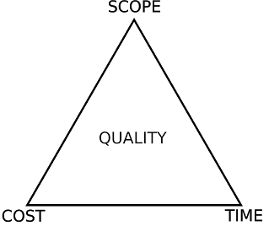Constraints are functions that can stop you or your organisation from meeting a business objective. We have explored this concept using the project management triangle which describes the relationship between three constraints:

* SCOPE
* TIME
* BUDGET/ COST

Note that quality is in the middle. Quality is impacted should one of the constraints have a detrimental effect on the work being carried out.

For examples, imagine you are deploying an IT suite of 30 machines. You have a budget of £10,000.00 and four weeks. The work can be done by you. It is possible to work within these constraints; they do not affect the validity and potential success of the project.

Now imagine the customer comes back to you and says that due to unforeseen circumstances you only have two weeks, instead of four. A constraint has changed. What effect could this have on the other constraints? What could be the potential impact on quality?

There are many more constraints that can affect progress towards an objective, think about your own organisation and try to identify constraints that affect you and the whole business.

## Quality

In your report you must also identify and make recommendation as to how the constraints can either be resolved or their impact minimised to ensure that quality is maintained. Would a bigger budget make a difference?

## Additional Resources

* [Hand-out 06 – Requirements and Specifications](http://1drv.ms/1xEQx31)
* [Customer Requirements Template](http://1drv.ms/14v1Q2Q)
* [Philosophe – Requirements and Specifications](http://philosophe.com/design/requirements/)
* [Wikipedia – Requirements Analysis](http://en.wikipedia.org/wiki/Requirements_analysis)
* [Agile Requirements Modelling](http://www.agilemodeling.com/essays/agileRequirements.htm)

**Evidence to be handed in:** Customer requirements report

# Task 2

## Criteria

*2.4 Recommend solutions for customer consideration*

*2.5 Explain the impact and implications of any changes to customer requirements*

*4.4 Describe file conversion issues that may arise during systems implementation*

*4.7 Describe the typical documentation provided on completion of implementation*

*5.1 Produce logical design specifications*

## Overview

Task 2 is about turning the information in task 1 into a technical document for the software developers. In other words brief for them to begin coding. Therefore you need to talk about how data will flow between terminals, buildings etc. (include a simple logical diagram showing data flow). What data needs to be collected on site and where it needs to go in order for head office to analyse it. It is likely that the raw data collected on site may have to be pulled into some sort of database along with data from other sites so reports can be generated by querying this database. File conversion issues may be due to you having to compress or encrypt data in order to transport it. You do not have to create a database.

(Analogy: how the website will be accessed by a browser rendering html code on files on a web server)

You will need to convert the requirements into specifications. Ensure that you link the specifications back to the customers’ needs and requirements to illustrate that they are relevant and meet the brief. How is the technical specification going to meet the users need?

You also need to document the logical design and data processes that will take place. For instance, if I as a trainer wanted to enter an apprentice’s attendance data, what would be the flow that would correspond to this? What might I see that another role might not and vice versa?

The process flow below is how a trainer might enter attendance marks, not that it is very simple. Should I wish to view the marks or produce reports consider how this process might be more complex.

There are few specific areas that you need to explain;

* **Issues that may arise with file conversion during systems implementation**
  + What systems might already exist? Are they using excel files to store their data? If so could you import this information in the MIS as a CSV?
* **Impact and implications that any changes many have on the customers’ requirements**
  + What opportunities or threats could affect the customers’ requirements?
* **Importance of the role of systems integration within the systems development process**
  + How might the MIS fit into the organisation processes? Might it change the way that they work?

You will need to identify the documentation that should be provided to the client on completion of the project. These are known as deliverables.

**Evidence to be handed in:** Requirements specification document

# Task 3

## Criteria

*1.1 Outline stages of the systems development life cycle*

*1.2 Explain the deliverables associated with systems development activities*

*1.3 Identify the sponsors and stakeholders involved in systems development and review*

*1.4 Explain the importance and role of systems integration to systems development process*

*4.1 Summarise the main stages of system implementation*

## Overview

Task 3 involves selecting an appropriate life cycle model and planning how the software will be designed, developed, tested etc. The Waterfall model is most appropriate here, as the steps follow the tasks. (Task 1 Requirements, Task 2 Design, Task 3 Implementation, Task 4 Verification, Task 5 Maintenance) As we are working to a time scale, a Gantt chart or similar would show how each task fits in and how long each should take. At this stage we are not yet rolling the software out to the customer, just testing that it works. You should also identify the stakeholders at each phase and explain what would be produced at each stage like documentation etc. (deliverables).You should also mention about how the software would be integrated with existing software and hardware. Planning for contingencies should also be built in.

(Analogy: testing the website works and can be accessed remotely)

You will need to demonstrate an understanding of the practical application of planning techniques using a number of varies tools and methodologies.

This should include:

* **Quality standards** – How will you maintain quality? What is the importance of quality and how will you know that you are maintaining it?
* **Contingencies** – This is your plan B, C, D, E etc. What will you do should part of or the entire project fail. Will you be able to fall back to the original system? How might you reduce the risk of a contingency plan needing to be implemented?
* **Time Frames** – Simple, what is the time frame of the project? What are the milestones and when are they due? You should assign deliverables to these milestones as evidence.

## GANTT Charts and PERT Analysis

Here is an example Gantt chart:

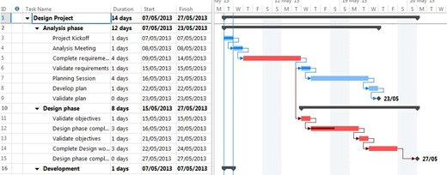

GANTT charts are really useful tools that can be used to plan and map out tasks/ activities and resources to a timeframe. Tasks can have dependencies that can form a critical path. Resources can be in the form of assets and people and they are things that allow work to be done.

You can learn more about GANTT charts here:

<http://en.wikipedia.org/wiki/Gantt_chart>

Here is an example of PERT chart:

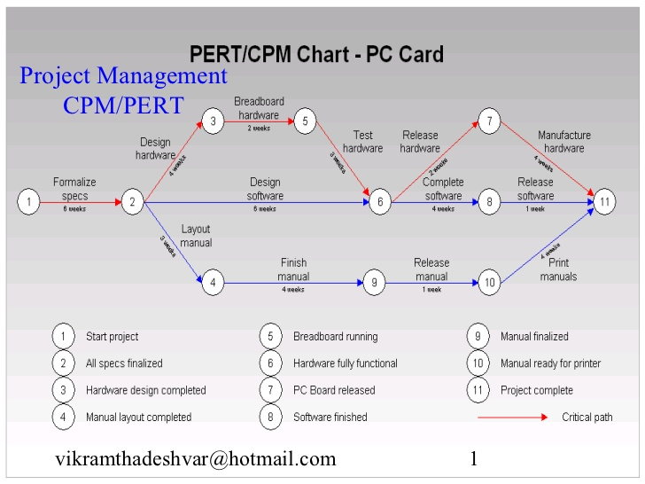

You can learn more about Critical Path Analysis and how to create a PERT chart here:

<http://www.mindtools.com/critpath.html>

**Evidence to be handed in:**

Planning documentation to include

* GANTT, PERT chart or similar that clearly identifies the stages of development
* Contingency planning document
* Diagrammatic outline of systems life cycle
* Comprehensive details of each stage of the selected life cycle
* Deliverables
* Test plan

# Task 4

## Criteria

*3.1 Explain the need for maintenance procedures*

*3.5 Explain how maintenance can affect the quality of ICT systems*

*4.2 Identify external factors that can affect implementation and handover activities*

*4.3 Evaluate different methods of system changeover*

*4.6 Describe user and support staff training requirements*

*4.8 Explain the purpose of version control procedures*

*5.2 Produce physical design specifications*

*6.1 Produce documentation for implementation*

*6.2 Test systems prior to rollout*

## Overview

Task 4 is producing a manual that gives detailed information about the handover to the client including system changeover, training for staff, maintenance etc.

(Analogy: handing website over to client with continues support/ maintenance)

(Reiteration from the assignment) You must justify the following:

Any policies/ procedures for data recovery:

* Agreed timescales
* Testing procedures
* Maintenance planning/ procedures
* Any security requirements
* Documentation required
* Training requirements
* The selected changeover methodology
* The arrangements for version control

**Evidence to be handed in:** System implementation procedure manual

# Task 5

## Criteria

*3.2 Describe the types of maintenance ICT systems may require*

*3.3 Produce maintenance procedure plans for ICT systems*

*3.4 Produce relevant documentation for recording maintenance activity*

## Overview

Task 5 requires you to detail the maintenance phase of the SLDC as it applies to the system that you have defined.

Please refer to the presentation materials on the L4 website for further detail.

**Evidence to be handed in:**

* Maintenance plan
* Maintenance activity recording forms